**Business establishment recommendation system based on country's economic freedom**

<https://github.com/gunasekharv6/Business-establishment-recommendation-system-based-on-country-s-economic-freedom/tree/main/DMDD%20Assignment%203>

Team “Northern Lights”

Gunasekhar Vinugolu - 001586178 git hub: [gunasekharv6](https://github.com/gunasekharv6)

Ajay Sureka - 002165619,

Mansi Dandgaval - 002956418,

Akhila Boppana - 001548272

**STEPS TO RUN THE FILE:**

Steps to run python file for exploratory data an alysis and data visualization:

1. Install Pycharm.

2. Set up the IDE and console.

Create a project to run the required files.

3. Install all the necessary packages/libraries as listed below:

Pandas

Numpy

Seaborn

Matplotlib

Sql-Alchemy

mysql.connector

pymysql

4. Export the EDA_Assignment3_DMDD.py file and run it on pycharm.

Note:

Some visualizations might take up more time to display depending on the size of the data being plotted.

**ERD:**

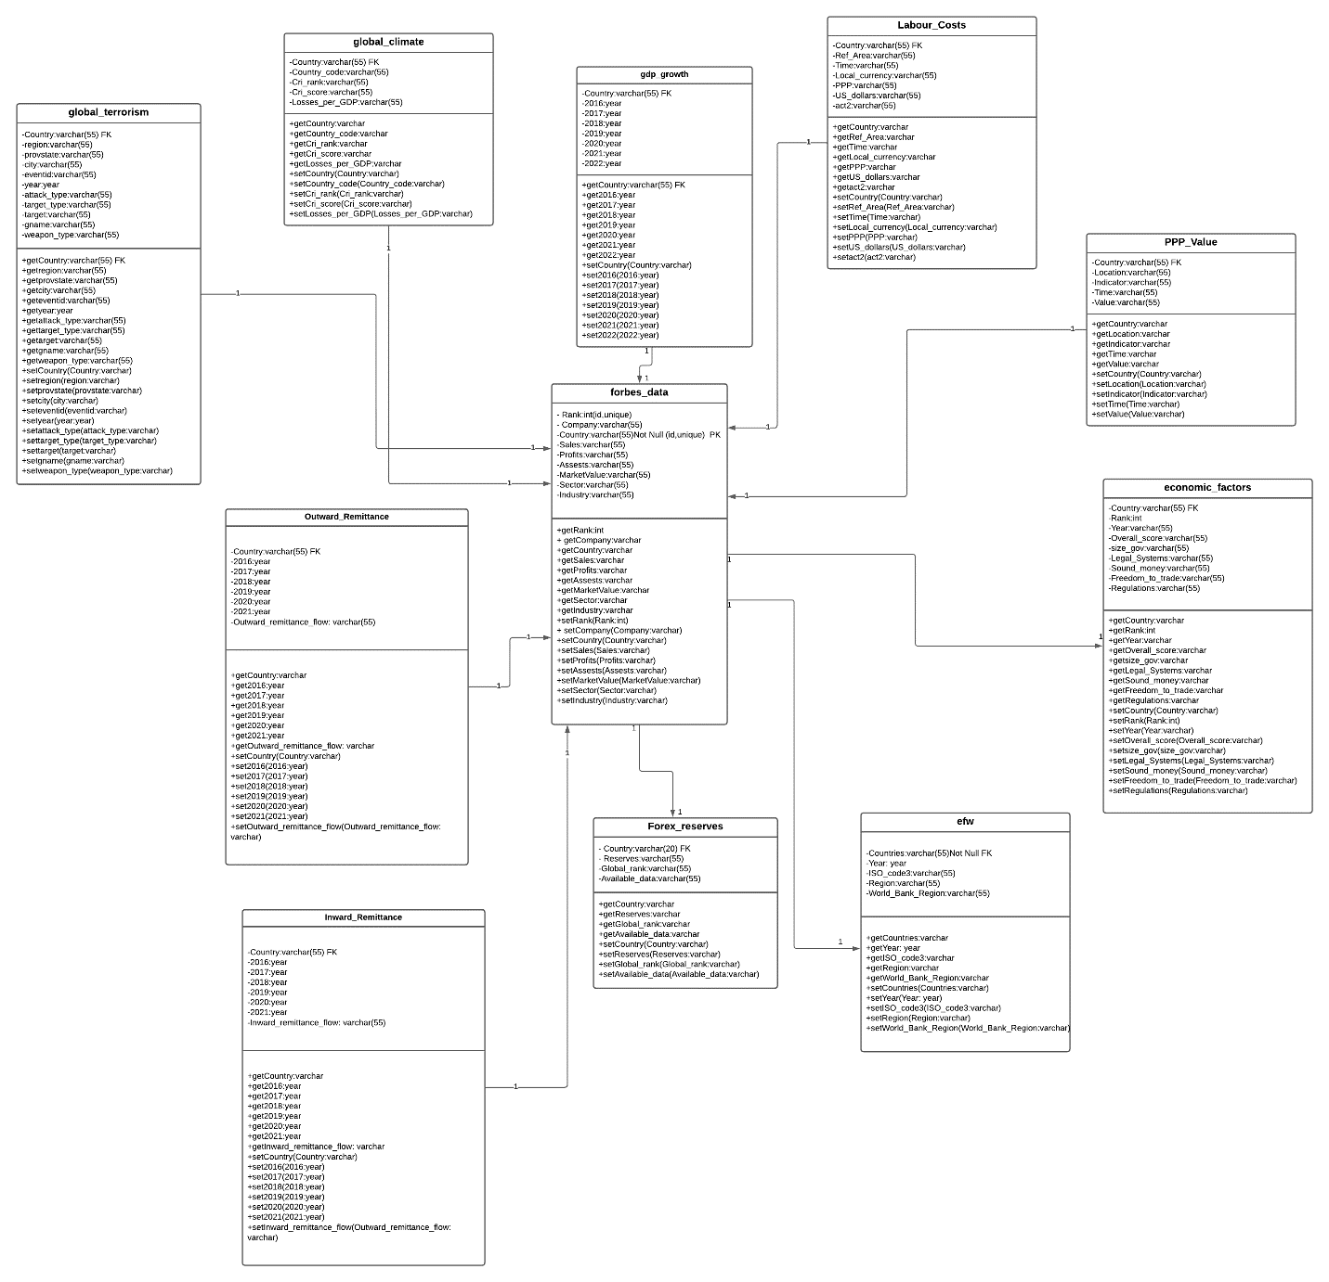

**USE CASES WITH SQL QUERIES:**

1. **Use Case:** Find country with particular sector and get the GDP rank associated with it

**Description:** User views the countries with respect to sector and their associated gdp

**Actor:** User

**Precondition:** User must have access to data

**Steps:**

**Actor action:** User views the countries with sector and their gdp

**System Responses:** the list of countries with sector and gdp are displayed

**Post Condition:** system displays the list of countries for the condition

**Error:** No country available

**SQL Query:**

SELECT * from((select * from yellow.forbes_data

where Company in ('JPMorgan Chase', 'Agricultural Bank of China', 'Charles Schwab') )A

Inner Join

(select * from yellow.gdp_growth)B

on A.`Country/Territory`=B.Country) ;

1. **Use Case:** Find country with top cri rank and their associated PPP value

**Description:** User views the countries with respect to cri rank and their associated PPP value

**Actor:** User

**Precondition:** User must have access to data

**Steps:**

**Actor action:** User views the countries with cri rank and their PPP value

**System Responses:** the list of countries with cri rank and PPP are displayed

**Post Condition:** system displays the list of countries for the condition

**Error:** No country available

**SQL Query:**

SELECT * from((select * from yellow.global_climate

where cri_rank=63)A

Inner Join

(select LOCATION, Value from yellow.ppp_value)B

on A.rw_country_code=B.LOCATION) LIMIT 1;

1. **Use Case:** Find countries with Financial sector and their associated Forex Reserves

**Description:** User views the countries with Financial sector and their associated Forex Reserves

**Actor:** User

**Precondition:** User must have access to data

**Steps:**

**Actor action:** User views the countries Financial sector and their associated Forex Reserves

**System Responses:** the list of countries with Financial sector and their associated Forex Reserves

**Post Condition:** system displays the list of countries for the condition

**Error:** No country available

**SQL Query:**

SELECT * from((select * from yellow.forbes_data

where Sector in ('Health Care', 'Financials', 'Materials'))A

Inner Join

(select * from yellow.Forex_Reserves)B

on A.`Country/Territory`=B.Countries ) ;

1. **Use Case:** Find countries with cri_rank more than 130 and their associated profits with sector

**Description:** User views the countries with with cri_rank more than 130 and their associated profits with sector

**Actor:** User

**Precondition:** User must have access to data

**Steps:**

**Actor action:** User views the countries with with cri_rank more than 130 and their associated profits with sector

**System Responses:** the list of countries with with cri_rank more than 130 and their associated profits with sector

**Post Condition:** system displays the list of countries for the condition

**Error:** No country available

**SQL Query:**

SELECT A.country, A.cri_rank, B.Company, B.Sector, B.Industry, B.Sales, B.Profits from(

(select * from yellow.global_climate

where cri_rank>130)A

Inner Join

(select `Country/Territory`,Company, Sector, Industry, Sales, Profits from yellow.forbes_data)B

on A.country=B.`Country/Territory`);

1. **Use Case:** Find companies with rank less than 20 with associated PPP, dollars and sector

**Description:** User views the companies with rank less than 20 with associated PPP, dollars and sector

**Actor:** User

**Precondition:** User must have access to data

**Steps:**

**Actor action:** User views the companies with rank less than 20 with associated PPP, dollars and sector

**System Responses:** the list of companies with rank less than 20 with associated PPP, dollars and sector

**Post Condition:** system displays the list of countries for the condition

**Error:** No country available

**SQL Query:**

Select * from

(SELECT country, Value from(

(select rw_country_code, country from yellow.global_climate)A

Inner Join

(select LOCATION, Value from yellow.ppp_value)B

on A.rw_country_code=B.LOCATION))C

Inner Join

(select * from yellow.forbes_data

where `Rank`<50)D

On C.country=D.`Country/Territory`;

1. **Use Case:** Find country named United States and itsGDP growth

**Description:** User views the country named United States and itsGDP growth

**Actor:** User

**Precondition:** User must have access to data

**Steps:**

**Actor action:** User views the country named United States and itsGDP growth

**System Responses:** the list of country named United States and itsGDP growth

**Post Condition:** system displays the list of countries for the condition

**Error:** No country available

**SQL Query:**

Select * from(

(select * from yellow.gdp_growth)A

Inner join

(select `Country/Territory`,Company, Sector, Industry, Sales, Profits from yellow.forbes_data)B

On A.Country= B.`Country/Territory`)

Where Sector='Energy';

1. **Use Case:** Find countries with sales more than $150B with profits greater than $10B get remittance.

**Description:** User views the countries with sales more than $150B with profits greater than $10B get remittance

**Actor:** User

**Precondition:** User must have access to data

**Steps:**

**Actor action:** User views the countries with sales more than $150B with profits greater than $10B get remittance

**System Responses:** the list of countries with sales more than $150B with profits greater than $10B get remittance

**Post Condition:** system displays the list of countries for the condition

**Error:** No country available

**SQL Query:**

select * from(

(select `Country/Territory`,Company, Sector, Industry, Sales, Profits from yellow.forbes_data

where Profits>'$10B')A

Inner Join

(select * from yellow.outward_remittance)B

on A.`Country/Territory` = B.`Outward remittance flows (US$ million)`);

1. **Use Case:** Find country named Japan get freedom to trade internationally their companies and market value of same

**Description:** User views the countries named Japan get freedom to trade internationally their companies and market value of same

**Actor:** User

**Precondition:** User must have access to data

**Steps:**

**Actor action:** User views the countries named Japan get freedom to trade internationally their companies and market value of same

**System Responses:** the list of countries named Japan get freedom to trade internationally their companies and market value of same

**Post Condition:** system displays the list of countries for the condition

**Error:** No country available

**SQL Query:**

select * from(

(select `Country/Territory`,Company, Sector, Industry, Sales, Profits from yellow.forbes_data

where Profits>'$10B'

and Industry in ('Regional Banks', 'Recreational Products'))A

Inner Join

(select * from yellow.labor_costs)B

on A.`Country/Territory` = B.`Reference area`);

1. **Use Case:** Find countries with financial sector with assets and associated legal systems and property rights with companies

**Description:** User views the countries with financial sector with assets and associated legal systems and property rights with companies

**Actor:** User

**Precondition:** User must have access to data

**Steps:**

**Actor action:** User views the countries with financial sector with assets and associated legal systems and property rights with companies

**System Responses:** the list of countries with financial sector with assets and associated legal systems and property rights with companies

**Post Condition:** system displays the list of countries for the condition

**Error:** No country available

**SQL Query:**

select * from(

(select `Country/Territory`,Company, Sector, Industry, Sales, Profits from yellow.forbes_data

where Profits>'$10B'

and Industry in ('Regional Banks', 'Recreational Products'))A

Inner Join

(select * from yellow.economic_factors)B

on A.`Country/Territory` = B.`COUNTRY NAME `);

1. **Use Case:** Find countries with sound money more than 1.4 and profits of the companies in the associated country

**Description:** User views the countries with sound money more than 1.4 and profits of the companies in the associated country

**Actor:** User

**Precondition:** User must have access to data

**Steps:**

**Actor action:** User views the countries with sound money more than 1.4 and profits of the companies in the associated country

**System Responses:** the list of countries with sound money more than 1.4 and profits of the companies in the associated country

**Post Condition:** system displays the list of countries for the condition

**Error:** No country available

**SQL Query:**

select * from(

(select `Country/Territory`,Company, Sector, Industry, Sales, Profits from yellow.forbes_data

where Profits>'$1.3B')A

Inner Join

(select * from yellow.economic_factors

where REGULATION >=8.3)B

on A.`Country/Territory` = B.`COUNTRY NAME `);

1. **Use Case:** Find country named India with outward remittance flow and companies in the country with government size

**Description:** User views the country named India with outward remittance flow and companies in the country with government size

**Actor:** User

**Precondition:** User must have access to data

**Steps:**

**Actor action:** User views the countries named India with outward remittance flow and companies in the country with government size

**System Responses:** the list of country named India with outward remittance flow and companies in the country with government size

**Post Condition:** system displays the list of countries for the condition

**Error:** No country available

**SQL Query:**

select * from(

(select * from yellow.outward_remittance)A

Inner Join

(select * from yellow.economic_factors

where REGULATION >=8.3)B

on A.`Outward remittance flows (US$ million)` = B.`COUNTRY NAME `);

1. **Use Case:** Find country named Canada and find PPP for the country and get associated international trade, regulations with profits made in which industry sector

**Description:** User views the country named Canada and find PPP for the country and get associated international trade, regulations with profits made in which industry sector

**Actor:** User

**Precondition:** User must have access to data

**Steps:**

**Actor action:** User views the named Canada and find PPP for the country and get associated international trade, regulations with profits made in which industry sector

**System Responses:** the list of country named Canada and find PPP for the country and get associated international trade, regulations with profits made in which industry sector

**Post Condition:** system displays the list of countries for the condition

**Error:** No country available

**SQL Query:**

SELECT Distinct A.country, A.cri_score, A.losses_per_gdp__rank from(

(select * from yellow.global_climate

where cri_score>=43.2)A

Inner Join

(select LOCATION, Value from yellow.ppp_value)B

on A.rw_country_code=B.LOCATION);

1. **Use Case:** Find countries with PPP value greater than 1 and year greater than 2000 with the sector, company and industry parameters associated with that country

**Description:** User views the countries with PPP value greater than 1 and year greater than 2000 with the sector, company and industry parameters associated with that country

**Actor:** User

**Precondition:** User must have access to data

**Steps:**

**Actor action:** User views the named Canada and find PPP for the country and get associated international trade, regulations with profits made in which industry sector

**System Responses:** the list of country named Canada and find PPP for the country and get associated international trade, regulations with profits made in which industry sector

**Post Condition:** system displays the list of countries for the condition

**Error:** No country available

**SQL Query:**

SELECT Distinct A.country, A.cri_score, A.losses_per_gdp__rank from(

(select * from yellow.global_climate

where cri_score>=43.2)A

Inner Join

(select LOCATION, Value from yellow.ppp_value)B

on A.rw_country_code=B.LOCATION);

1. **Use Case:** Find countries with local currency greater than 5 with associated industry, company and sector

**Description:** User views the countries with local currency greater than 5 with associated industry, company and sector

**Actor:** User

**Precondition:** User must have access to data

**Steps:**

**Actor action:** User views the the countries with local currency greater than 5 with associated industry, company and sector

**System Responses:** the list of countries with local currency greater than 5 with associated industry, company and sector

**Post Condition:** system displays the list of countries for the condition

**Error:** No country available

**SQL Query:**

SELECT * from(

(select * from yellow.forbes_data)A

Inner Join

(select * from yellow.labor_costs

where `Local currency`>5)B

on A.`Country/Territory`=B.`Reference area`);

1. **Use Case:** Find country named Italy and company, sector and industry with profits, legal systems & property rights associated with it

**Description:** User views the country named Italy and company, sector and industry with profits, legal systems & property rights associated with it

**Actor:** User

**Precondition:** User must have access to data

**Steps:**

**Actor action:** User views the country named Italy and company, sector and industry with profits, legal systems & property rights associated with it

**System Responses:** the list of countries named Italy and company, sector and industry with profits, legal systems & property rights associated with it

**Post Condition:** system displays the list of countries for the condition

**Error:** No country available

**SQL Query:**

SELECT * from(

(select * from yellow.forbes_data)A

Inner Join

(select * from yellow.economic_factors)B

on A.`Country/Territory`=B.`COUNTRY NAME `)

Where `Country/Territory` = 'Italy';

1. **Use Case:** Find country with maximum forex reserves and its gdp data

**Description:** User views the country with maximum forex reserves and its gdp data

**Actor:** User

**Precondition:** User must have access to data

**Steps:**

**Actor action:** User views the country with maximum forex reserves and its gdp data

**System Responses:** the country with maximum forex reserves and its gdp data is populated

**Post Condition:** system displays the list of countries for the condition

**Error:** No country available

**SQL Query:**

SELECT * from(

(select * from yellow.forex_reserves)A

Inner Join

(select * from yellow.gdp_growth)B

on A.`Countries `=B.Country)

order by A.`Global rank ` LIMIT 1;

1. **Use Case:** Select the country with max inward remittance in 2021 and their gdp

**Description:** User views the countries with max inward remittance in 2021 and their gdp

**Actor:** User

**Precondition:** User must have access to data

**Steps:**

**Actor action:** countries with max inward remittance in 2021 and their gdp

**System Responses:** countries with max inward remittance in 2021 and their gdp

**Post Condition:** system displays the list of countries for the condition

**Error:** No country available

**SQL Query:**

SELECT * from(

(select * from yellow.outward_remittance)A

Inner Join

(select * from yellow.gdp_growth)B

on A.`Outward remittance flows (US$ million)`=B.Country)

order by B.`2022` Desc Limit 10 ;

1. **Use Case:** View the country with top 10 gdp in 2021 and their corresponding forex reserves

**Description:** User views the countries with top 10 gdp in 2021 and their corresponding forex reserves

**Actor:** User

**Precondition:** User must have access to data

**Steps:**

**Actor action:** countries with top 10 gdp in 2021 and their corresponding forex reserves

**System Responses:** countries with with top 10 gdp in 2021 and their corresponding forex reserves

**Post Condition:** system displays the list of countries for the condition

**Error:** No country available

**SQL Query:**

SELECT * from(

(select * from yellow.forex_reserves)A

Inner Join

(select * from yellow.gdp_growth)B

on A.`Countries `=B.Country)

WHERE B.Country in ('China', 'India', 'France', 'Germany')

order by B.`2022` DESC LIMIT 5;

1. **Use Case:** User makes a search for country with lowest labor cost along with their gdp

**Description:** User views the countries with lowest labor cost along with their gdp

**Actor:** User

**Precondition:** User must have access to data

**Steps:**

**Actor action:** countries with lowest labor cost along with their gdp

**System Responses:** with lowest labor cost along with their gdp

**Post Condition:** system displays the list of countries for the condition

**Error:** No country available

**SQL Query:**

SELECT * from(

(select * from yellow.labor_costs)A

Inner Join

(select * from yellow.gdp_growth)B

on A.`Reference area`=B.Country)

order by A.`U.S. dollars` LIMIT 1;

1. **Use Case:** User makes a search for country with maximum terror attacks their gdp

**Description:** User views the countries with maximum terror attacks their gdp

**Actor:** User

**Precondition:** User must have access to data

**Steps:**

**Actor action:** countries with maximum terror attacks their gdp

**System Responses:** countries with maximum terror attacks their gdp

**Post Condition:** system displays the list of countries for the condition

**Error:** No country available

**SQL Query:**

SELECT * from(

(select country_txt,Count(eventid) Total_attacks from yellow.global_terrorism

group by country_txt)A

Inner Join

(select * from yellow.gdp_growth)B

on A.country_txt=B.Country)

order by Total_attacks Desc;

**AUDITING:**

**Audited all the data sets with individual auditing of each file that can be found below**

Output10: audited the contents of file with no duplicate contents

And also ensure that all the parameters result are out of 10

Output9: audited the contents of the data ensuring that all the figures are in million dollars

Output7: audited the contents of the data ensuring that the figures are consistent as per million dollars

Ouput6: verified all the content of the data. All the currency parameters are in dollars (that is money is not in Euros or rupees)

Ouput5: verified all the parameters and found data consistent

Output4: verified the consistency of data and data is consistent with respect to currency exchange rates

Ouput3: Deleted unnecessary column rank in output 3

Output2: audited date all the parameter consistent with data